Welcome to the Salesforce Marketing Cloud

Table of Contents
Welcome to Salesforce Marketing Cloud! 4
Pre-requisites 4
Critical Concepts 5
User Definitions 2
Scope by User vs. Non-Scope by User 2
Marketing Cloud Fundamentals 5
A. Account Login and Navigation 5
B. Marketing Cloud Home Page Navigation 5
Member Account ID (MID) 5
2. Marketing Cloud Home Page Navigation 6
C. Email Navigation 7
1. Email Application Home Page 7
2. Email Application Workspace 8
3. Creating Folders 9
D. Security Settings 10
E. My Users 12
F. Sender Profile 13
G. Delivery Profile 14
H. Send Classification 15
I. BrandBuilder 16
Step 2: Salesforce Marketing Cloud Connector Configuration 18
A. Tracking User 18
B. Installation 19
C. Trusted IP Ranges 20
D. Enable the Salesforce Marketing Cloud Connector for Admin User 21
F. Workflows 22
a. Scheduled Send Workflow 22
b. Backup Workflow 22
G. User Configuration 23
a. Existing Users 23
H. User Flow Chart 24
I. Triggered Sends Objects 25
Step 3: Subscribers 27
A. Subscribers Rule 27
B. Identify Data Sources Outside of salesforce.com 27
C. Identifying Profile and Preference Attributes 28
1. Profile Attributes 28
2. Preference Attributes 30
D. Managing Lists 31
1. Subscribers Tab 32
2. Properties Tab 33
33
3. Tracking Tab 34
Step 4: Creating Your Email 36
A. Path to Email Success 36
B. Portfolio 36
1. Content Organization 36
C. Email Building Checklist 38
D. Template Selection 39
E. Content Forms 42
Step 6: Testing & Sending Email 48
A. Workflow 49
B. Before you Send 49
C. Test Sending 50
D. Sending Your Email 51
Step 5: Tracking Your Email 54
A. What is tracking? 54
A. Tracking Grid 55
B. Creating Lists from Tracking Data 56
C. How to Share 57

Welcome to Salesforce Marketing Cloud!

This workbook was designed to welcome you to the Marketing Cloud and assist you as you begin your path to power 1:1 customer journeys using the Salesforce Marketing Cloud Connector.

We invite you to join the Getting Started with the Salesforce Marketing Cloud Connector Webinar Series (https://webevents.force.com/s/marketing-cloud.html) where we share how to get you up and running with the Marketing Cloud Connector. The 6 steps in this workbook align to the 6 webinars in the series.

Before we begin your Getting Started with the Salesforce Marketing Cloud Connector, we want to make sure to cover some pre-requisites and critical concepts to understand.

Pre-requisites
- One of the following salesforce.com editions set up: Unlimited, Enterprise, or Performance. Person Accounts are supported. Please Note: Professional Edition is not supported by the Salesforce Marketing Cloud Connector. Professional Edition is supported in v2.
- Must have one of the following Salesforce Marketing Cloud accounts: Core, Advanced, Enterprise, Enterprise 2.0, or Reseller Edition. Please Note: On-Your-Behalf (OYB) accounts are not supported.
- The Business Rules for the Salesforce Marketing Cloud Connector is turned on for your Salesforce Marketing Cloud account. If you need assistance, please contact your Salesforce Marketing Cloud Account Executive to have the integration turned on in your account.
- Have administrator credentials/permissions for salesforce.com and the Salesforce Marketing Cloud.
- Four (4) customer tabs available in salesforce.com.
- Create a report that defines an intended Send To list. For example, you could create a report that returns only your contact record for testing purposes.
- Install the most recent version of Chrome or Firefox browsers.
- Subscriber Key is required for the Salesforce Marketing Cloud Connector. If it is not active in your account you will need to go through the Subscriber Key Migration before proceeding with the Salesforce Marketing Cloud Connector connection process. For more information about Subscriber Key, please go here.
- Users must have Read Access to Salesforce Marketing Cloud package object; Read Access to Contacts, Leads, Campaigns, and Reports; Read Access to any objects that are related to the Salesforce Marketing Cloud objects or the standard objects.
- Include the minimum permissions required at the profile level to create an API user between the Salesforce Marketing Cloud and Salesforce.com using the Salesforce Marketing Cloud AppExchange Package. These include:

Administrative Permissions
API Enabled
API Only User
Chatter Internal User
Password Never Expires
Schedule Reports
View Help Link
View Reports in Public Folder
General User Permissions
Allow View Knowledge – This permission is checked by default by the system
Export Reports
Report Builder
Run Reports

Critical Concepts
Before proceeding with the Salesforce Marketing Cloud installation and implementation, it is imperative that you understand two (2) critical concepts: User Definitions and Scope by User vs. Non-Scope by User.

User Definitions
With the Salesforce Marketing Cloud Connector, there are five (5) types of users.
- Salesforce Marketing Cloud Connector API User
This is the Admin user in Salesforce Marketing Cloud whose credentials are used to set up the integration between your Salesforce Account and your Salesforce Marketing Cloud Account. These are the user credentials you will use when you initially configure the Salesforce Marketing Cloud Connector after installation. It is recommended that this be a dedicated system user.
- Salesforce Tracking User
The Tracking User’s credentials in Salesforce are used by the Salesforce Marketing Cloud as the primary mechanism for retrieving data from within Salesforce as well as pushing data back into Salesforce. This user does not perform sends. The sole purpose of the Tracking User is to create the “handshake” between Salesforce and the Salesforce Marketing Cloud’s email tracking information using the Tracking User’s credential. It is recommended that this be a dedicated system user. Note: The Tracking User must have the System Administrator profile. This is subject to change.
- Marketing Cloud for AppExchange Admin
This is a user in Salesforce who can perform sends and see all views of data. This user can send to any contact, lead, campaign, or report.
- Marketing Cloud for AppExchange User
The user in Salesforce who can perform sends in Salesforce. This user is typically not an administrator. If you are using Scope by User (see below), this user’s view is restricted to the records they own. They can only send to records they own.
- Marketing Cloud User
This is a user in the Salesforce Marketing Cloud that must be mapped to a Salesforce user who is performing sends out of Salesforce.

There needs to be a one-to-one relationship between Salesforce and Salesforce Marketing Cloud for users who will be performing sends in Salesforce. For example, if you a Salesforce user wants to perform a send from Salesforce, they must also be a user in the Salesforce Marketing Cloud.

Scope by User vs. Non-Scope by User
There are two (2) types of user configurations in the Salesforce Marketing Cloud Connector.
- Non-Scope by User
- Scope by User
Use the following information to choose an appropriate user configuration for your organization.
Non-Scope by User
With this configuration, subscribers who are visible or accessible to the Tracking User can be retrieved from Reports or Campaigns. Often, the Tracking User is an Administrator within Salesforce with wide-ranging access. Thus, the list of subscribers returned from each Report or Campaign includes all subscribers visible to the Tracking User. Subscribers are not filtered based on the user running the report.
Examples:
- If a user creates a report based on My Contacts, the Tracking User cannot see the contacts in that report. The report would be empty and none of the contacts in the report would be sent to. No error is thrown, but the subsequent Email Send report would show “0” contacts sent.
- If a user accesses an existing report that contains records shared by the user and other users, the user will only see his or her own records. If that user sends to that report intending only to send to the records they see, they could inadvertently send to additional shared records.

Considerations:
Review the following reasons to decide if this configuration is best for your organization:
- The send behavior described above is the default behavior for SFV2 accounts, making this a favorable option for existing SFV2 customers who wish to migrate to the Salesforce Marketing Cloud Connector.
- Within the Salesforce Marketing Cloud, Report and/or Campaign lists are not limited to what is visible to the user initiating the send.
- Within the Salesforce Marketing Cloud, returned Subscribers are not limited to only those visible to the user initiating the send.
- Password policies are not in effect, making this configuration easy to maintain because passwords do not expire.
- An administrator can set up users without entering a password.
- Potential Risk: A user could mistakenly send to Report and/or Campaign members who are not visible to that user without notice.

Scope by User
With this configuration, Reports and Campaigns that are visible to the user initiating the send are available for selection within the Salesforce Marketing Cloud as a target audience for Reports or Campaigns. Subscribers are filtered based on the user initiating the send. The list of Subscribers returned is limited to what the user initiating the send has access to view.
Review the following reasons to decide if this configuration is best for your organization:
- Within the Salesforce Marketing Cloud, Report and/or Campaign lists are limited to what is visible by the user initiating the send.
- The send behavior described above is the default behavior for SFV3 accounts, making this a favorable option for existing SFV3 customers who wish to migrate to the Salesforce Marketing Cloud Connector.
- Users must enter their Salesforce password during the Integrate User process in the Salesforce Marketing Cloud.
- When a user’s Salesforce password expires, that user must update their Salesforce password in the Salesforce Marketing Cloud.

Marketing Cloud Fundamentals

Account Login and Navigation
Use this worksheet to access the email application and navigate through everyday situations.
You’ll want to ensure that you have the correct username and password. If you do not have this information, you’ll need to reach out to your account administrator or Global Support at help@exacttarget.com.

- Marketing Cloud Home Page Navigation

Now let’s determine how to find out account information. In the top right corner you will see your account name. Hover over your account name to find your Member Account ID, or MID. You will need to know your MID when you are logging a case with Global Support.

- Member Account ID

Member Account ID (MID)

- Marketing Cloud Home Page Navigation

For the next activity you will get the chance to navigate through the Marketing Cloud homepage. Take a minute to label the different areas of the homepage and highlight areas that you would like to learn more about or think might be helpful to understand.
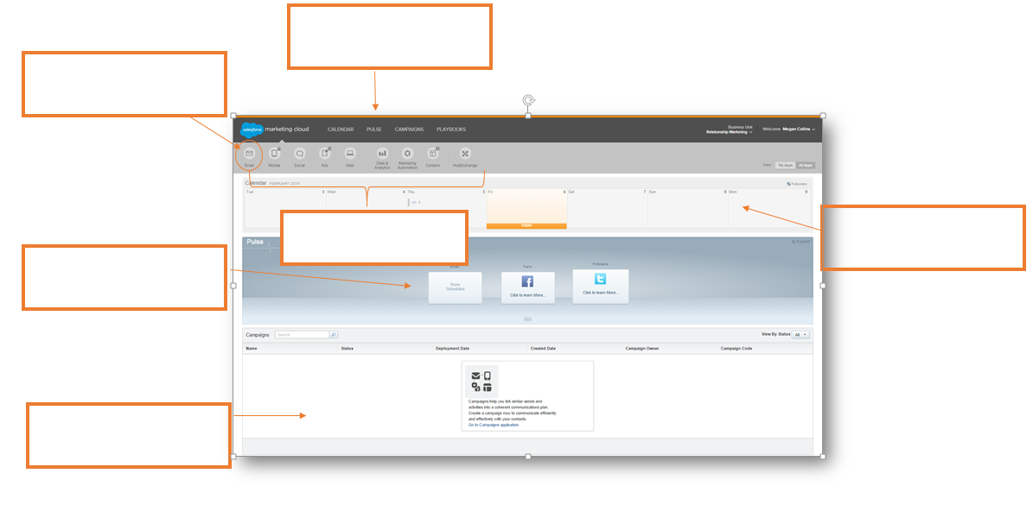

- Email Navigation

Follow along with the webinar to fill in the two diagrams below including the Email application home page and inside the Email application workspace.
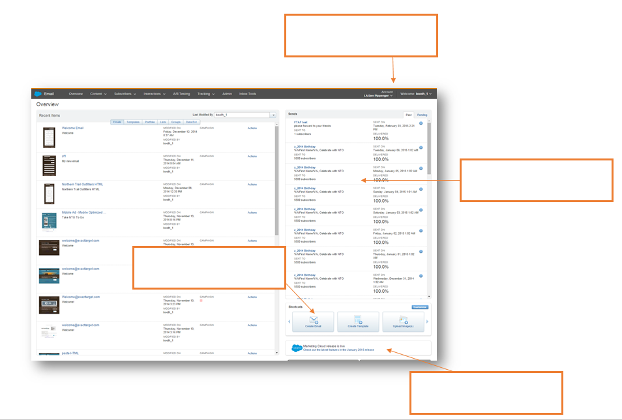
- Email Application Home Page

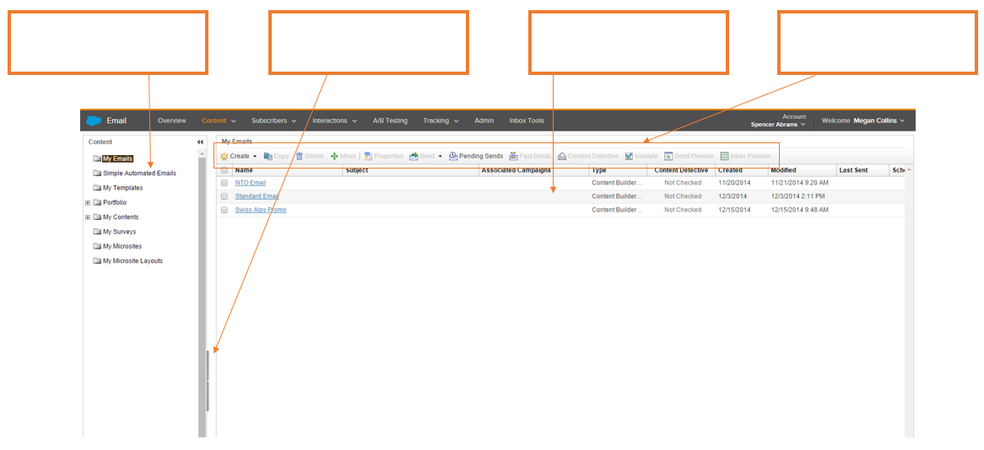
- Email Application Workspace

- Creating Folders

Take time now to organize your thoughts. Jot down the folders you plan to make so you can keep organized in the application. You can use the following questions to get you thinking.
- What kind of campaigns will you be sending?
- Will you break it down by season/quarter?
- Do you have a series of emails that could be a folder?
- Would you rather group it by content? Accessories, Shoes, Women, Men etc.

Creating your Folders
Folder Title | What’s included

- Security Settings

Use the following activity to identify how you will manage your security settings. You may need to reach out to another department to set the correct security options for your company.

Manage your Security Settings
When would you like your session to automatically timeout? | 20 min 1 hr 2 hrs 4 hrs 8 hrs
Does your account require secure connections? | Yes or No
Do you want your login to expire after inactivity? | 30 days 60 days 90 days 1 year Never
How many login attempts are acceptable before a lockout? | 3 5 10
Do you want your account to count invalid logins across sessions? | Yes or No
What is your minimum username length? | 4 6 8 10
How long do you want your Device Activation Code lifetime to be?
How long do you want your device to be inactive before it requires reactivation?
What is your minimum password length? | 6 8 10
How complex do you want your password to be? | How many alpha?  How many numeric?  How many special characters?
How many passwords do you want your account to remember?
When do you want your user password to expire? | 30 days 60 days 90 days 1 year Never
Do you want to exclude API users from password expiration? | Yes or No
Would you like a password change confirmation email? | Yes or No

- My Users

In this activity you’ll think through the different users that you will need for your account. Think about the different permissions they will need in order to be successful. If you need more information on permissions please visit help.exacttarget.com
When defining the people in your organization that will have access to the Email application, below are some items to be thinking about:
- Who, in your company, is going to access the Salesforce Marketing Cloud Email Application?
- Each user in the Email application has a role that determines what tasks they can complete.
- What roles need to be created for your company?

Before you start building users in your account, list and define the users and their properties.

Username | Full Name | Reply Email | Access | Permissions | Temporary PW

- Sender Profile

Let’s think about what your From Names will look like for your campaigns. Do not delete or rename the Default Sender Profile to ensure the integration with salesforce.com works appropriately.

From Name Discovery
Is your From name a user from the drop down menu? | Yes or No
Do you need to add a specific name in? | Yes or No
If you need a specific name, what will it be? | a.  b.  c.  d.
Do you have permission to use this name and email? | Yes or No

- Delivery Profile

It is important to know the difference between a Commercial Email and a Transactional Email. Let’s review that now!
CAN- SPAM
The Assault of Non- Solicited Pornography and Marketing Act, or the CAN-SPAM Act, that is the US federal standards
Commercial emails are when the primary purpose of the message is to deliver commercial content. These MUST include your physical mailing address and provide an opt-out/unsubscribe mechanism.
Examples from your program include:
Transactional emails are when the primary purpose is to deliver transactional content. An unsubscribe link is not required in transactional messages.
Examples from your program include:

Each Email and or Campaign will have specific header and footer requirements. Let’s get your requirements in order for your first email. Do not delete or rename the Default Delivery Profile to ensure the integration with salesforce.com works appropriately.

Email Name | Associated Campaign | Header | Footer

- Send Classification

Let’s get more specific. Which emails do you have that are Commercial and which emails do you have that are Transactional?

Reminder: If you choose to use a unique header, note that you will have to create a new content area.

Email | Type | Sender Profile | Delivery Profile
Commercial
Transactional
Commercial
Transactional
Commercial
Transactional
Commercial
Transactional
Commercial
Transactional

- BrandBuilder

BrandBuilder is a private labeling tool that allows you to provide a branded experience to both your application users and your subscribers. Take the time now to make sure you have built your brand to the highest standards!

BrandBuilder Checklist
Action Items | Completed | Need Review
Add your logo/header background color to every screen, including the login screen
Change the color scheme of the primary navigation buttons
Brand your survey and Forward to a Friend landing pages as well as the Profile and Subscription Center

Still have questions? List out your open questions below and use help.exacttarget.com to find your answers. If you run into any difficulties finding answers, remember you can always reach out to Global support at help@exacttarget.com .

Have a question about your account? We have an answer.
Questions | Answers

Step 2: Salesforce Marketing Cloud Connector Configuration
- Tracking User
A tracking user allows your salesforce.com and Salesforce Marketing Cloud accounts to communicate with each other by creating a “handshake” between the two. Use the checklist below to make sure your tracking user is set up correctly:

Tracking User Checklist
Action Item | Completed
Create User
Role Selected
User license is set to Salesforce
Profile set to System Administrator

Identify your tracking user below:

Tracking User Username | Tracking User Email Address

- Installation
The next step is to complete the installation of the package. Use the following checklist to make sure you don’t miss a step!
Installation Checklist
Action Item | Completed
Download the install package
Approved Third Party Access
Approved Package API Access
Select Security Level

Reminder: You can access the install package at the following URL:
https://login.salesforce.com/packaging/installPackage.apexp?p0=04ti0000000Tba0

- Trusted IP Ranges
The following IP ranges need to be added to the Trusted IP Ranges section in the Network Access tab under Security Controls in your salesforce instance. It is important that the IP ranges match the ranges below exactly for the integration to work properly.
Starting IP Range | Ending IP Range | Added
64.79.134.164 | 64.79.134.164
66.231.91.195 | 66.231.91.195
66.231.91.251 | 66.231.91.251
66.231.94.247 | 66.231.94.247
66.231.94.250 | 66.231.94.252
68.232.200.1 | 68.232.200.2
68.232.203.56 | 68.232.203.63
68.232.204.99 | 68.232.204.99
99.50.81.121 | 99.50.81.140
136.147.128.1 | 136.147.128.14
136.147.129.15 | 136.147.129.15
136.147.131.11 | 136.147.131.18
184.72.230.214 | 184.72.230.214
199.122.126.99 | 199.122.126.99
206.246.157.1 | 206.246.157.6
207.67.53.64 | 207.67.53.78
207.67.66.192 | 207.67.66.222
207.67.98.216 | 207.67.98.216
207.250.76.176 | 207.250.76.183
207.250.79.96 | 207.250.79.110
209.43.14.97 | 209.43.14.97

- Enable the Salesforce Marketing Cloud Connector for Admin User

The next step is to enable your Admin User to access the Salesforce Marketing Cloud Connector within Salesforce. To do so, navigate to the User Edit screen and ensure the appropriate checkboxes are marked in the Additional Information section.
Admin User(s) | Enabled
Marketing Cloud for AppExchange Admin
Marketing Cloud for AppExchange User

You will also need to enable the Salesforce Marketing Cloud Connector for all users you’d like to have access to the Salesforce Marketing Cloud Connector from within Salesforce. For general users, you will follow the same steps for Admin Users but will only check the Marketing Cloud for AppExchange User checkbox.
- Customization of Page Layouts
In order to access the integration within salesforce.com, you will need to customize the page layouts for objects within your salesforce.com instance. Use the checklist below to keep track of the page layouts you have updated:
Object | Layout Updated
User Page
Custom Links on Account, Contacts, and/or Leads Page
Related Lists on Account, Contacts, and/or Leads Page
Custom Fields on Contact and/or Leads Page
Custom Links on Campaign Page
Related Lists on Campaign Page

- Workflows
Workflow rules are critical to any organization because they give you the ability to enforce key business processes easily without having to write code. Let’s break down the process for you, so you clearly understand how to create a workflow rule. For the Email Send process you will need to create 2 workflow rules.

  - Scheduled Send Workflow

Scheduled Send Workflow | Checklist
- Select Email Send
- Enter Rule Name: ScheduledSend
- Enter Evaluation Criteria: Created
- Run this rule if the following: Criteria are Met
- Field Settings- Email Send: Scheduled Date/Time is not equal to Blank
- Add Time Trigger: 0 Hours After Email Send Scheduled Date/Time
- Add Workflow Action
- Select Existing Action
- Choose Field Update Action
- Add Field Update: DelayedSend
- Activate Workflow Rule
  - Backup Workflow

Backup Workflow | Checklist
- Select Email Send
- Enter Rule Name: BackupWorkflow
- Enter Evaluation Criteria: Created, and any time it’s edited to subsequently meet criteria
- Run this rule if the following: Criteria are Met
- Field Settings- Email Send: Backup Workflow Date/Time is not equal to Blank
- Add Time Trigger: 0 Hours After Email Send Backup Workflow Date/Time
- Add Workflow Action
- Select Existing Action
- Choose Field Update Action
- Add Field Update: UnpopulateBackupWorkflow
- Activate Workflow Rule

- User Configuration
In order to complete the next step of the integration you will need to configure your Users. There are 3 different users that you need to integrate. Let’s review those now

User | Reasoning
Salesforce Tracking User in the Marketing Cloud | The tracking user is the first user you will configure in your Marketing Cloud account. This username is your Salesforce credentials that you used to set up your Marketing Cloud Connector Integration. This creates a 1:1 relationship, meaning that one Marketing Cloud Account is associated with one Salesforce.com User
API User in the Marketing Cloud | An API user is the “handshake” between the two instances.
Existing User in the Marketing Cloud | These are users that already have a Marketing Cloud account that you would like to add the Marketing Cloud Connector.

  - Existing Users
Existing Users is one of the users that you will need to integrate. Take the time now to think of which users will benefit from being integrated with the Salesforce Marketing Cloud Connector.
Users | How will they benefit from the MC Connector?

- User Flow Chart
Integrating different accounts can get confusing. Please refer to the following diagram to see how to best integrate your user.

- Triggered Sends Objects
Triggered Email Sends allows Marketing Cloud Connector customers to create and send automated messages to Salesforce contact, lead or person account records when object records are created and/or updated. For this exercise you will need to decide which objects you will use for Triggered Email Sends. This comes into play in the webinar when you create APEX codes for each object and then add the objects in the triggered send options.
Object | Needed for Triggered Email Sends
Contact
Lead
AB Test
Business Unit
Campaign Manager
User
Aggregate Link Level
Account
Case
Email Send
Email Linkage
Event
Task
Mobile Send

- Salesforce System Configuration
The last step in the configuration section, is to complete the configuration work within your salesforce.com instance. Use the checklist below to make sure you don’t miss a configuration step:
Salesforce System Configuration
Action Item | Completed
Add Tabs
Select Send Types
Select Send Options
Select Triggered Send Options
Select Business Units (only applicable to Enterprise 2.0 Marketing Cloud accounts)
Salesforce.com User Setup

Step 3: Subscribers

Subscribers Rule
Which of the following is not a part of Subscribers Rule:

Serve yourself
Honor their unique preference with regard to communication, content, frequency & channels
Deliver them timely, relevant content that improves their lives
Serve the individual

Identify Data Sources Outside of salesforce.com

For this activity, you can list the data sources that you will use for your first send. (if any)

File Name | Data Source | Notes

Identifying Profile and Preference Attributes

Profile Attributes

Take a moment to define your profile attributes. Think of all of the fields that you will need to power your targeted, relevant communications and for your future filters and groupings.

Examples: Birthday, gender, location etc.
 |  | Profile Attributes
Attribute | Type |  | Required | Default | Hidden | Read-Only | Salesforce Field | Default Value
Email | Text
Full Name | Text
User Defined | Boolean
Attribute | Type |  | Required | Default | Hidden | Read-Only | Salesforce Field | Default Value

Preference Attributes

Take a moment to think about the possible ways you can use preference attributes to power your campaigns. Remember, preference attributes are yes / no scenarios.

Example: HTML, Monthly Newsletters, New Product Announcements etc.

 |  | Preference Attributes
Attribute | Default |  | Hidden |  | Read-Only |  | Salesforce Field |  | True or False
HTML Email

Managing Lists

Let’s think about what communications you can manage with lists? In the table below, outline the lists you will need to create in your account.

Example: Monthly Newsletter, Weekly Specials, New Products or Class information etc.

Lists | Description

- List Management

Follow along with the webinar to navigate through a list’s properties, subscribers and tracking information. Fill in the blanks for the diagrams below for each section.

Subscribers Tab

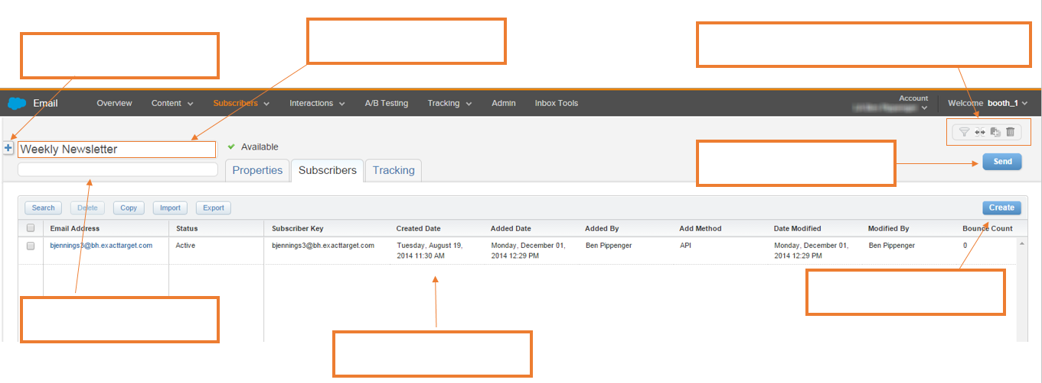
The Subscribers tab is the initial screen you will see when you choose a list. Here you will see all of the subscribers included in your list. Fill in the blanks to get a better idea of how to manage your lists.

Properties Tab
The properties tab shows general information about your list and also shows a count of how many subscribers are in the list. Fill in the blanks to learn more about your list’s properties.
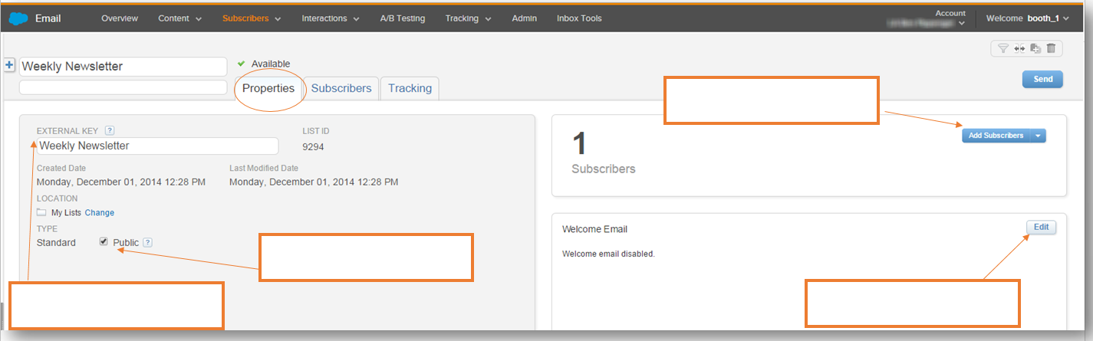

Tracking Tab
The tracking tab is the final step of your list navigation. Here you will see the most recent sends as well as your list composition. Fill in the blanks to see how you can track the subscribers in your list.
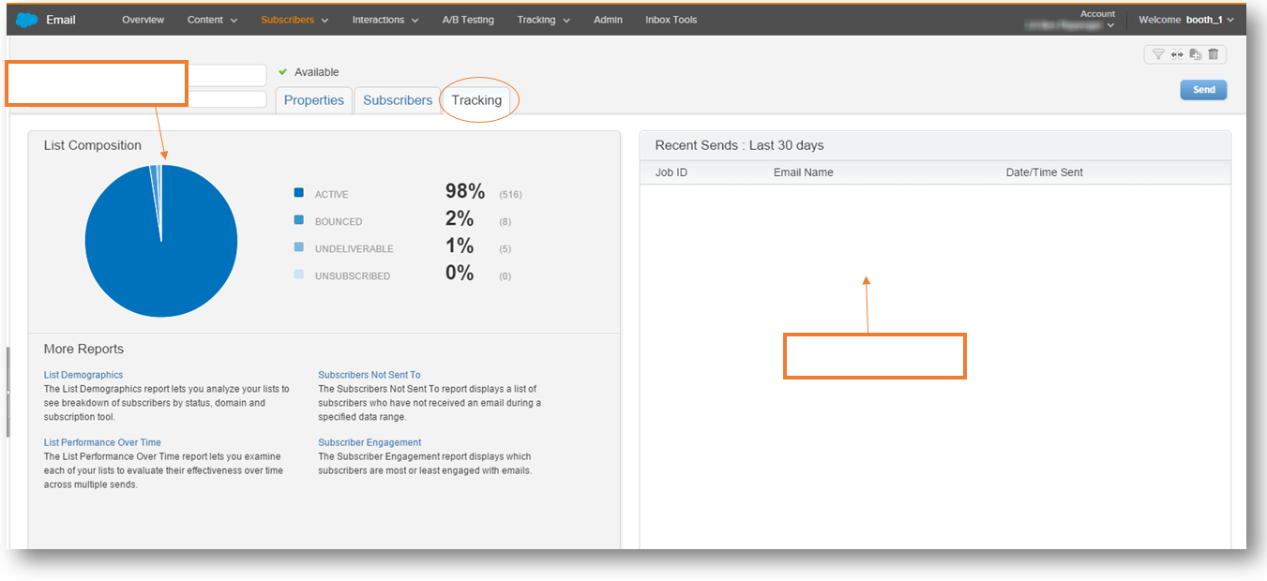

Still have questions? List out your open questions below and use help.exacttarget.com to find your answers. If you run into any difficulties finding answers, remember you can always reach out to Global support at help@exacttarget.com .

Have a question about your account? We have an answer.
Questions | Answers

Step 4: Creating Your Email

Path to Email Success

You’ve learned a lot! Let’s take a second to review the Path to Email Success. In this section we will be focusing on getting organized with Portfolio, creating templates and making sure you have everything ready to send your email.

Portfolio

Content Organization

For the next activity, let’s think of how you are going to organize your Content. Outline your folder structure within Portfolio and how you plan on utilizing the folders.

Content Organization
Folder Name | Images Included | Content Included | Media Files Included
Folder Name | Images Included | Content Included | Media Files Included

Email Building Checklist

Before you get started building an email, let’s make sure you have everything you need. Refer to this checklist as you begin building your emails and before you know it, you’ll be a pro!

Email Checklist
Are all of your images created?
Have you checked the file types that are supported?
Have you created a banner?
Do you have all of your content uploaded into Portfolio?
Do you have your content placement identified?
How many images/ content areas will you need?
Have you chosen a template?
Have you reviewed the Template Size Guidelines
Will you need to build HTML code outside of the app? | Y or N
Do you know your hexidecimal color codes?
Do you know the border color for the banner, if needed?
Do you know the background color, if needed?
Do you have a header that is less than 600 pixels?
Do you have a subject line?
Do you have your preheader identified?

Template Selection

Trying to figure out what templates work for you? Go ahead and pick a few that you think might be useful for different emails.

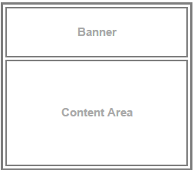
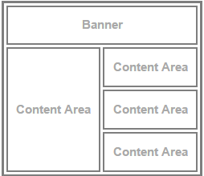
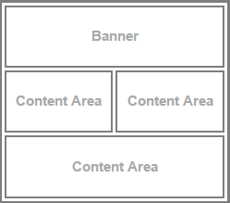
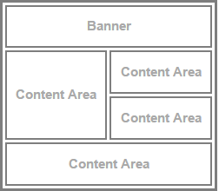

A ________________ B _________________ C _________________ D _________________

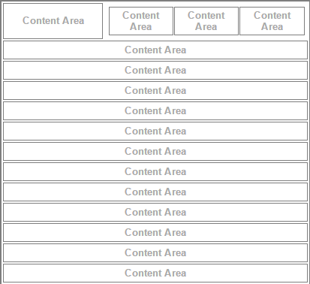
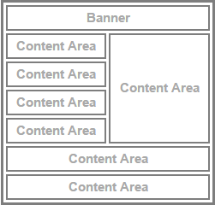
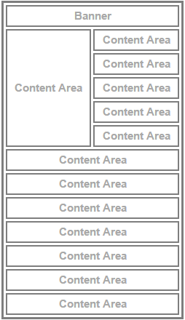
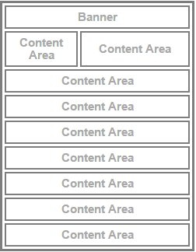

E _________________ F _________________ G _________________ H _________________
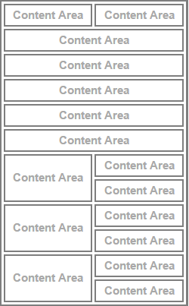
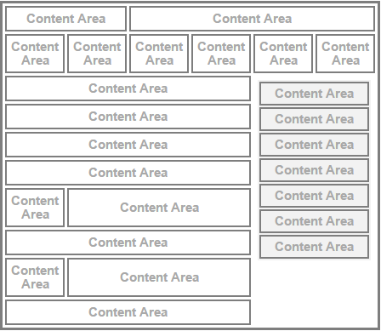

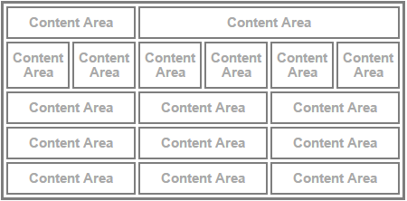

I _________________ J _________________ K _________________

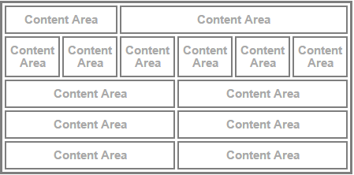
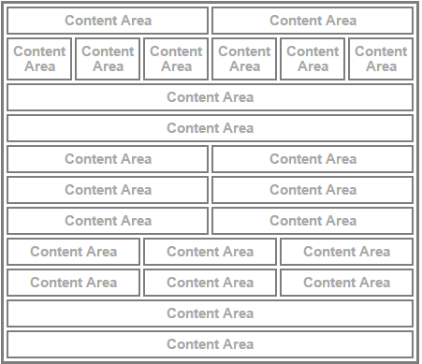

L _________________ M __________________

Content Forms

Consider the different forms of content and list how you can utilize them in your emails
Content Forms | How will you use them?
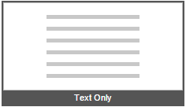
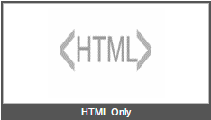

- Hexidecimal Color Code

Use this next activity to gather the correct hexadecimal color codes for your emails. Then you’ll be able to quickly refer back to it if you need to add a spice of color! Different colors may need to be used for different parts of your email.
Example: FFFFFF used for Border Color

Hexidecimal Color Code
Code # | When to use this color

- HTML Checklist

In order to create an HTML template, you need ensure the appropriate additions are made to your HTML code. Use this as a checklist to have a completed HTML code before creating a template.

HTML Checklist
Email Open Tracking
Content Areas
Tracking Alias
CAN-SPAM Compliance
Personalization Strings

Still have questions? List out your open questions below and use help.exacttarget.com to find your answers. If you run into any difficulties finding answers, remember you can always reach out to Global support at help@exacttarget.com .

Have a question about your account? We have an answer.
Questions | Answers

Step 6: Testing & Sending Email

- Workflow

Below is a diagram for the workflow you will walk through when testing and sending an email.

- Before you Send

You want to make sure you send the perfect email. This list will help you

Before you Send Checklist
Review the deliverability tips to ensure that your email reaches as many subscribers as possible.

Run the Spell Check in the content areas in your email. This is done within each content box by clicking the Spell Check icon, or by selecting Edit > Check Spelling.

Preview your email using Send Preview

Run Content Detective and make any necessary updates
Validate your email
Perform a test delivery of your email

- Test Sending

Before you begin testing, think about who you want to receive your test emails. These may include subscribers who are approvers, key stakeholders, and additional members of your email team.

List the email addresses that you would like your test emails to be sent to. You can send to up to 5 email addresses at one time.

Test Email Addresses
1.
2.
3.
4.
5.

Sending Your Email

Each type of send option has different steps. Let’s keep organized by referring to the following guides for each unique type of send.
Test Send | Simple Send | Guided Send
From the send menu, select Test Send | From the send menu, select Simple Send | From the send menu, select Guided Send
Enter up to five email addresses to receive the test send | Review Subject and From Name, select a List for sending, and a send data and time | Click Next on the first screen of the Wizard
Click Send | Click Send | Select the list(s) or group(s) to send to
Confirmation is displayed on screen | Confirm Send | Select Exclusion Lists (if required)
 |  | Modify the subject, From Options, Send Options, and Test Options (if required)
 |  | Select to send the email immediately, or schedule for a specific date and time
 |  | Review and confirm the configuration
 |  | Click Send
 |  | Confirmation is displayed in the wizard when your email has been sent/scheduled. Click Finish

Still have questions? List out your open questions below and use help.exacttarget.com to find your answers. If you run into any difficulties finding answers, remember you can always reach out to Global support at help@exacttarget.com .

Have a question about your account? We have an answer.
Questions | Answers

Step 5: Tracking Your Email

What is tracking?

Tracking is an aggregated collection of data that allows you to view critical elements. Which of the following elements do you think will help you track your emails?

Tracking Elements |  | How will it help?
Deliverability Rate
Undeliverables
Unique Opens
Total Opens
Open Rate
Unique Clicks
Total Clicks
Click Rate
Unengagement
Conversions
Surveys
Forward to a Friend Activity

- Tracking Grid

Which of the following elements do you think will help you track your emails and would be most valuable to having included in your workspace? Select which columns to display in the Tracking grid.

Tracking Grid
ID |  | Total Clicks
Name (This column is required to be visible) |  | Unique Click-Through Rate
Subject |  | Open Rate
From Name |  | Undeliverables
Date/Time Sent (This column is required to be visible) |  | Deliverability Rate
Status |  | Unsubscribes
Emails Sent |  | Unsubscribes Rate
Delivered |  | Survey Responses
Unique Opens |  | Unique Conversions
Total Clicks |  | Total Conversions
Unique Clicks |  | FTAF-Forwarders
Total Clicks |  | FTAF- Recipients
 |  | FTAF- Subscribers

- Creating Lists from Tracking Data

Creating a list from your tracking data is very important. Follow along with the steps below to get you through your first list creation, then you’ll be a pro!

Creating a List from Tracking Data
- Click the hyperlinked item you would like to create a list for
- Click Copy All in the toolbar
- Select to add to an Existing List or New List
    - Existing List: Select the list from the dropdown
    - New List: Enter a Name, description and visibility
- Click Copy

- How to Share

Certain tabs allow you to create a PDF, Excel file or both. Before starting to track your subscriber data you’ll need to know what form of tracking information your team or certain individuals would like to view. Use the below table to help outline who you will send tracking to, how you will send it over, and how frequently you will send it.

Tracking Information
Team or Employee Name | Document Type | How often do they need it?
 | PDF Excel | Daily Weekly Bi Weekly Monthly Bi Monthly Other ________________________
 | PDF Excel | Daily Weekly Bi Weekly Monthly Bi Monthly Other ________________________
 | PDF Excel | Daily Weekly Bi Weekly Monthly Bi Monthly Other ________________________
 | PDF Excel | Daily Weekly Bi Weekly Monthly Bi Monthly Other ________________________
 | PDF Excel | Daily Weekly Bi Weekly Monthly Bi Monthly Other ________________________
 | PDF Excel | Daily Weekly Bi Weekly Monthly Bi Monthly Other ________________________
 | PDF Excel | Daily Weekly Bi Weekly Monthly Bi Monthly Other ________________________
 | PDF Excel | Daily Weekly Bi Weekly Monthly Bi Monthly Other ________________________
 | PDF Excel | Daily Weekly Bi Weekly Monthly Bi Monthly Other ________________________

Still have questions? List out your open questions below and use help.exacttarget.com to find your answers. If you run into any difficulties finding answers, remember you can always reach out to Global support at help@exacttarget.com .

Have a question about your account? We have an answer.
Questions | Answers

