Welcome to the Salesforce Marketing Cloud – Social Studio

Table of Contents

Step 1: Marketing Cloud- Social Studio Fundamentals
- Account and Login Navigation 2
- Social Studio Welcome Page Navigation 2
1. Organization Name 2
- Social Studio Welcome Page Navigation Activity 3
C. Admin Setting Navigation 4
- Security Settings 5
- Creating Workspaces 6
- My Users 7
- Workspace Settings Navigation 8
Questions 9

Step 2: Listen & Analyze

Analyze Dashboard 10
  - Dashboard Types 11
  - Card Types 11

Topic Profiles 12
Questions 13

Step 3: Publish
- Publish Navigation 14
- Content Creation 15
- Approval Rules 16
- Content Forms 17
Questions 18

Step 4: Engage
- Engagement Navigation 19
- Tabs 20
- Workflow 21
Questions 22

Welcome to Salesforce Marketing Cloud!

This workbook was designed to welcome you to Social Studio and assist you as you begin your path to harnessing the power of social.

You can use this workbook to follow along while you set up your account and get a general overview of the platform.

- We invite you to join the Getting Started with Social Studio Webinar Series (https://webevents.force.com/s/marketing-cloud.html) where we share how to get you up and running with Social Studio. The 4 steps in this workbook align to the 4 webinars in the series.

Step 1: Marketing Cloud- Social Studio Fundamentals

Account Login and Navigation
Use this worksheet to access the Social Studio application and navigate through everyday situations.

You’ll want to ensure that you have the correct username and password. If you do not have this information, you’ll need to reach out to your account administrator or Global Support at mailto:MarketingCloudSupport@salesforce.com

- Social Studio Welcome Page Navigation

Now let’s determine how to find out account information. In the top right corner you will see your name. Click on your name and a drop down box will appear. Your organization name or Tenant as it is sometimes referred, is under your name in this drop down box. It is within the grey area. It helps to know your Organization name when you are logging a case with Global Support. Record it here:

- Organization Name (Tenant name)

Organization Name

- Social Studio Welcome Page Navigation

For the next activity you will get the chance to navigate through the Social Studio homepage. Take a minute to label the different areas of the homepage and highlight areas that you would like to learn more about or think might be helpful to understand.
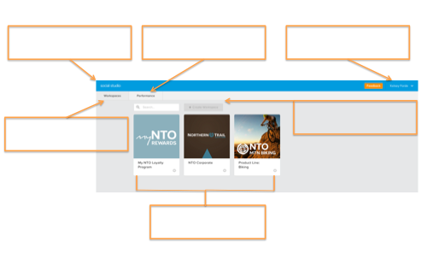

- Admin Setting Navigation

Follow along with the webinar to fill in the diagram below.

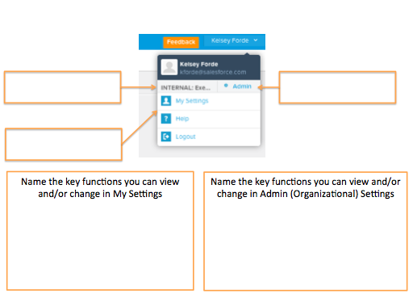

- Security Settings

Use the following activity to identify how you will manage your security settings. You may need to reach out to another department to set the correct security options for your company.

Manage your Security Settings
When would you like your session to automatically timeout? | 15 min 30 min 1 hr 2 hrs 4 hrs 8 hrs

- Creating Workspaces

Take time now to organize your thoughts. Jot down the workspaces you plan to make so you can keep organized in the application. You can use the following questions to get you thinking.
- How many workspaces will you need?
- What social accounts will be attached to each workspace?
- Should the workspaces be segmented by team? Topic? Program?

Creating your Workspaces
Workspace Title | What’s included

- My Users

In this activity you’ll think through the different users that you will need for your account. Think about the different permissions they will need in order to be successful. If you need more information on permissions please visit our Help and Training portal.
When defining the people in your organization that will have access to the Social Studio application, below are some items to be thinking about:
- Who, in your company, is going to access the Salesforce Marketing Cloud Social Studio application?
- Each user in the Social Studio application has an organizational role that determines what tasks they can complete.
- Each user also has workspace permissions assigned to them that determines what tasks they can complete within their assigned workspaces

Before you start building users in your account, list and define the users and their properties.

Username | Full Name | Reply Email | Organizational Role | Assigned Workspaces | Workspace Permissions

- Workspace Settings Navigation

For the next activity you will get the chance to navigate around your workspace settings. . Take a minute to label the different areas of the workspace and highlight areas that you would like to learn more about or think might be helpful to understand.

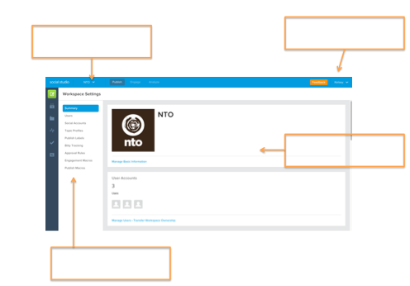

Still have questions? List out your open questions below and use help.salesforce.com to find your answers. If you run into any difficulties finding answers, remember you can always reach out to Global support at mailto:MarketingCloudSupport@salesforce.com.

Have a question about your account? We have an answer.
Questions | Answers

Step 2: Listen & Analyze

Analyze Dashboard

Take a minute to label the various aspects of the Analyze Dashboard.

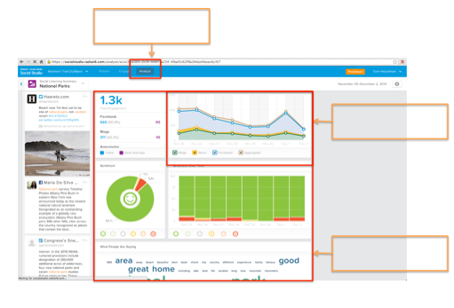

Dashboard Types

For this activity, list the four types of dashboards currently available to build within Analyze

1. | 3.
2. | 4.

Card Types

Label the following card types.

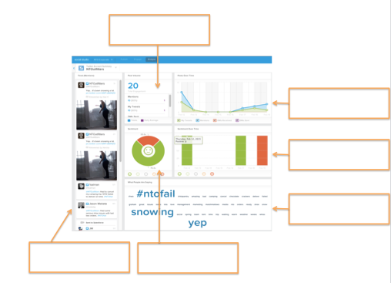

Topic Profiles

Take a moment to think about the possible ways you can use Topic Profiles to power your social listening. What types of information do you want to listen for? Are there specific use cases (ie: support, HR recruitment, lead gen), competitors, company campaigns that you want target. Use this activity to jot down your ideas

Topic Profile Ideas
Use Case | Media Types | Language(s) | Geographic |  | Key Words

Still have questions? List out your open questions below and use help.salesforce.com to find your answers. If you run into any difficulties finding answers, remember you can always reach out to Global support at mailto:MarketingCloudSupport@salesforce.com.

Have a question about your account? We have an answer.
Questions | Answers

Step 3: Publish

Publish Navigation

Let’s review the key components of the Publish tab. Follow along with the webinar to fill in the boxes and take notes on areas you would like more information on.

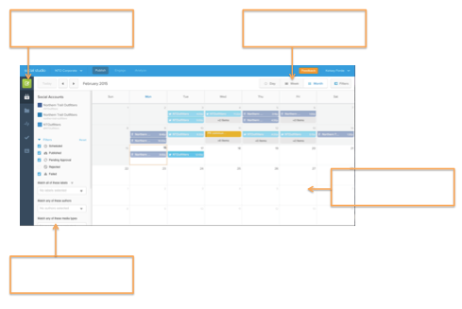

Content Creation

For the next activity, let’s think of how you are going to create and distribute your content. Outline your content, the appropriate workspace and the social channels you will use to publish it.

Content Organization
Workspace Name | Images / Media files Included | Content Included | Social Channel
Workspace Name | Images / Media files Included | Content Included | Social Channel

Approval Rules

Before you get started publishing content, think about any approval rules you may want to set up for your users. Can anyone publish content or should the appropriate authorities approve the content first? Use this section to jot down any approval rules you will want to set up.

Approval Rule Name | Criteria/ Condition Trigger | Approvers

Still have questions? List out your open questions below and use help.salesforce.com to find your answers. If you run into any difficulties finding answers, remember you can always reach out to Global support at mailto:MarketingCloudSupport@salesforce.com.

Have a question about your account? We have an answer.
Questions | Answers

Step 4: Engage

- Engagement Navigation

Label the following diagram.
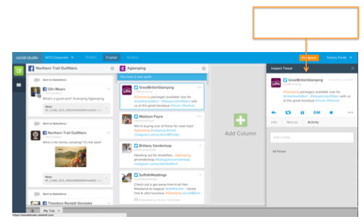
Name seven actions you can perform within the Post Inspector:
1.
2.
3.
4.
5.
6.
7.

- Tabs

Tabs are a great way to organize the social conversations you’re most interested in following and responding to. Take a minute to jot down ideas for the tabs you may want to create.

Tab Name | Social Accounts | Purpose
Example: Customer Support | Facebook – NTO Customer Care  Twitter – NTO Support | Identify and respond to customer issues

How many tabs and columns can you create?
- 5
- 10
- 20
- unlimited

- Workflow

Workflow can be used in many ways to label posts and route them to the appropriate teams. Depending on your business you may want to ensure some posts get a personalized response while other posts just need to be labeled for reporting purposes. The workflow process you decide on depends on your business goals and objectives. For this next exercise think about how you might apply workflow to route and label incoming posts. Note: To increase processing time, once you establish your workflow procedures, you can convert them to macros.

Post Type  (Example: customer post, competitor mention) | Workflow process  (Example: Sentiment, label name) | Team Responsible

Still have questions? List out your open questions below and use help.salesforce.com to find your answers. If you run into any difficulties finding answers, remember you can always reach out to Global support at mailto:MarketingCloudSupport@salesforce.com.

Have a question about your account? We have an answer.
Questions | Answers

