Welcome to the Salesforce Marketing Cloud

Table of Contents

Step 1: Marketing Cloud Fundamentals
- Account and Login Navigation 2
- Marketing Cloud Home Page Navigation 2
1. Member Account ID (MID) 2
- Marketing Cloud Home Page Navigation Activity 3
- Email Application 4
- Email Application Home Page 4
- Email Application Workspace 5
- Creating Folders 6
- Security Settings 7
  - Manage your Security Settings 7
- My Users 9
  - Defining your Users 9
- Sender Profile 10
  - Identify From Names 10
- Delivery Profile 11
  - CAN-SPAM 11
  - Header & Footer requirements 11
- Send Classification 12
  - Commercial vs. Transactional 12
- Brand Builder 13
Questions 14

Step 2: Subscribers
- Subscribers Rule 15
- Identifying Data Sources 15
- Identifying Profile & Preference Attributes 16
- Profile Attributes 16
- Preference Attributes 18
- Managing Lists 19
- List Management 20
- Subscribers Tab 20
- Properties Tab 21
- Tracking Tab 22
Questions 23

Step 3: Creating Your Email
- Path to Email Success 24
- Portfolio 25
- Content Organization 25
- Email Building Checklist 27
- Template Creation 28
  - Template Samples 28
- Content Forms 30
- Hexidecimal Color Code 32
- HTML Checklist 33
Questions 34

Step 4: Testing & Sending Email
- Workflow 35
- Before you Send 36
  - Before you send checklist 36
- Test Sending 37
  - Test Email Addresses 37
- Sending your Email 38
  - Send Type Breakdown Chart 38
Questions 39

Step 5: Sending & Tracking
- What is Tracking? 40
  - Tracking Elements 40
- Tracking Grid 41
  - Tracking Grid Preferences 41
- Creating Lists from Tracking Data 42
- How to Share 43
  - How to send your Tracking Information 43
Questions 44

Welcome to Salesforce Marketing Cloud!

This workbook was designed to welcome you to the Marketing Cloud and assist you as you begin your path to power 1:1 customer journeys.

You can use this workbook to follow along while you set up your account and get a general overview of the platform.

- We invite you to join the Getting Started with Email Webinar Series (https://webevents.force.com/s/marketing-cloud.html) where we share how to get you up and running with the Marketing Cloud. The 5 steps in this workbook align to the 5 webinars in the series.

Marketing Cloud Fundamentals

Account Login and Navigation
Use this worksheet to access the email application and navigate through everyday situations.

You’ll want to ensure that you have the correct username and password. If you do not have this information, you’ll need to reach out to your account administrator or Global Support at help@exacttarget.com.

- Marketing Cloud Home Page Navigation

Now let’s determine how to find out account information. In the top right corner you will see your account name. Hover over your account name to find your Member Account ID, or MID. You will need to know your MID when you are logging a case with Global Support.

- Member Account ID

Member Account ID (MID)

- Marketing Cloud Home Page Navigation

For the next activity you will get the chance to navigate through the Marketing Cloud homepage. Take a minute to label the different areas of the homepage and highlight areas that you would like to learn more about or think might be helpful to understand.
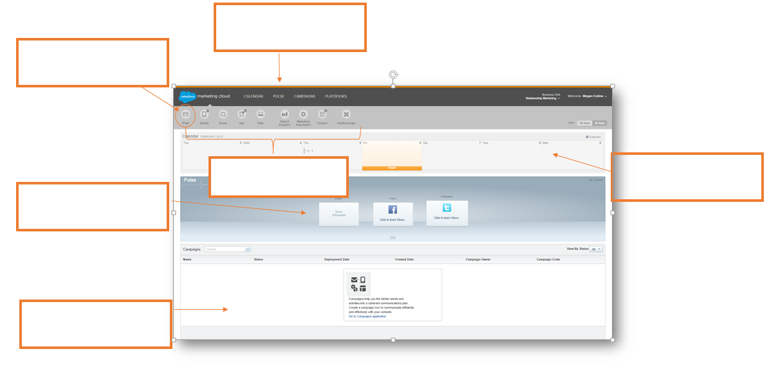

- Email Navigation

Follow along with the webinar to fill in the two diagrams below including the Email application home page and inside the Email application workspace.
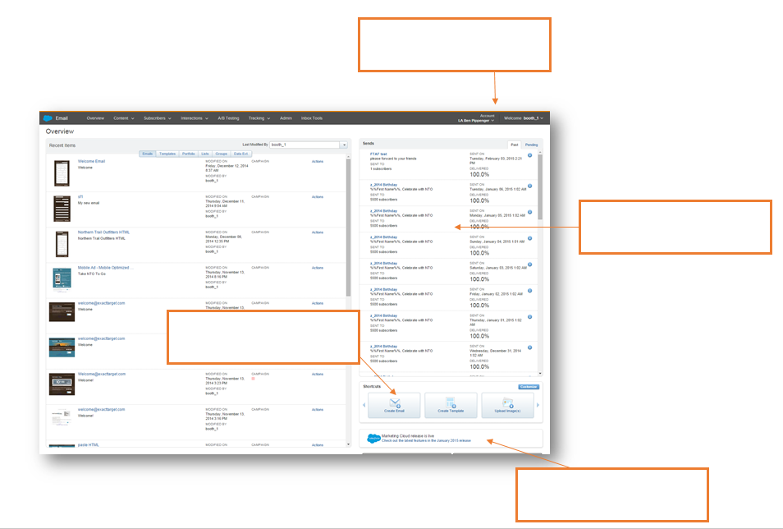
- Email Application Home Page

- Email Application Workspace

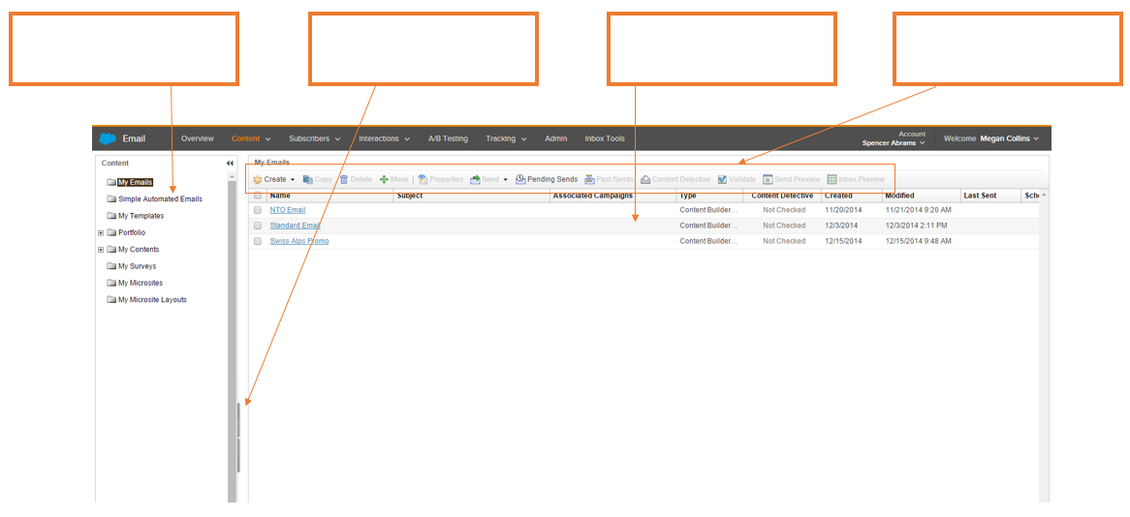

- Creating Folders

Take time now to organize your thoughts. Jot down the folders you plan to make so you can keep organized in the application. You can use the following questions to get you thinking.
- What kind of campaigns will you be sending?
- Will you break it down by season/quarter?
- Do you have a series of emails that could be a folder?
- Would you rather group it by content? Accessories, Shoes, Women, Men etc.

Creating your Folders
Folder Title | What’s included

- Security Settings

Use the following activity to identify how you will manage your security settings. You may need to reach out to another department to set the correct security options for your company.

Manage your Security Settings
When would you like your session to automatically timeout? | 20 min 1 hr 2 hrs 4 hrs 8 hrs
Does your account require secure connections? | Yes or No
Do you want your login to expire after inactivity? | 30 days 60 days 90 days 1 year Never
How many login attempts are acceptable before a lockout? | 3 5 10
Do you want your account to count invalid logins across sessions? | Yes or No
What is your minimum username length? | 4 6 8 10
How long do you want your Device Activation Code lifetime to be?
How long do you want your device to be inactive before it requires reactivation?
What is your minimum password length? | 6 8 10
How complex do you want your password to be? | How many alpha?  How many numeric?  How many special characters?
How many passwords do you want your account to remember?
When do you want your user password to expire? | 30 days 60 days 90 days 1 year Never
Do you want to exclude API users from password expiration? | Yes or No
Would you like a password change confirmation email? | Yes or No

- My Users

In this activity you’ll think through the different users that you will need for your account. Think about the different permissions they will need in order to be successful. If you need more information on permissions please visit help.exacttarget.com
When defining the people in your organization that will have access to the Email application, below are some items to be thinking about:
- Who, in your company, is going to access the Salesforce Marketing Cloud Email Application?
- Each user in the Email application has a role that determines what tasks they can complete.
- What roles need to be created for your company?

Before you start building users in your account, list and define the users and their properties.

Username | Full Name | Reply Email | Access | Permissions | Temporary PW

- Sender Profile

Let’s think about what your From Names will look like for your campaigns.

From Name Discovery
Is your From name a user from the drop down menu? | Yes or No
Do you need to add a specific name in? | Yes or No
If you need a specific name, what will it be? | a.  b.  c.  d.
Do you have permission to use this name and email? | Yes or No

- Delivery Profile

It is important to know the difference between a Commercial Email and a Transactional Email. Let’s review that now!
CAN- SPAM
The Assault of Non- Solicited Pornography and Marketing Act, or the CAN-SPAM Act, that is the US federal standards
Commercial emails are when the primary purpose of the message is to deliver commercial content. These MUST include your physical mailing address and provide an opt-out/unsubscribe mechanism.
Examples from your program include:
Transactional emails are when the primary purpose is to deliver transactional content. An unsubscribe link is not required in transactional messages.
Examples from your program include:

Each Email and or Campaign will have specific header and footer requirements. Let’s get your requirements in order for your first email.

Email Name | Associated Campaign | Header | Footer

- Send Classification

Let’s get more specific. Which emails do you have that are Commercial and which emails do you have that are Transactional?

Reminder: If you choose to use a unique header, note that you will have to create a new content area.

Email | Type | Sender Profile | Delivery Profile
Commercial
Transactional
Commercial
Transactional
Commercial
Transactional
Commercial
Transactional
Commercial
Transactional

- BrandBuilder

BrandBuilder is a private labeling tool that allows you to provide a branded experience to both your application users and your subscribers. Take the time now to make sure you have built your brand to the highest standards!

BrandBuilder Checklist
Action Items | Completed | Need Review
Add your logo/header background color to every screen, including the login screen
Change the color scheme of the primary navigation buttons
Brand your survey and Forward to a Friend landing pages as well as the Profile and Subscription Center

Still have questions? List out your open questions below and use help.exacttarget.com to find your answers. If you run into any difficulties finding answers, remember you can always reach out to Global support at help@exacttarget.com .

Have a question about your account? We have an answer.
Questions | Answers

Step 2: Subscribers

Subscribers Rule

Which of the following is not a part of Subscribers Rule:

Serve yourself

Honor their unique preference with regard to communication, content, frequency & channels

Deliver them timely, relevant content that improves their lives

Serve the individual

Identify Data Sources

For this activity, you can list the data sources that you will use for your first send.

File Name | Data Source | Notes

Identifying Profile and Preference Attributes

Profile Attributes

Take a moment to define your profile attributes. Think of all of the fields that you will need to power your targeted, relevant communications and for your future filters and groupings.

Examples: Birthday, gender, location etc.

Profile Attributes
Attribute | Type | Required | Default | Hidden |  | Read-Only |  | Default Value
Email | Text
Full Name | Text
User Defined | Boolean
Attribute | Type | Required | Default | Hidden | Read-Only |  | Default Value

Preference Attributes

Take a moment to think about the possible ways you can use preference attributes to power your campaigns. Remember, preference attributes are yes / no scenarios.

Example: HTML, Monthly Newsletters, New Product Announcements etc.

Preference Attributes
Attribute | Default | Hidden |  | Read-Only |  | True or False
HTML Email

Managing Lists

Let’s think about what communications you can manage with lists? In the table below, outline the lists you will need to create in your account.

Example: Monthly Newsletter, Weekly Specials, New Products or Class information etc.

Lists | Description

List Management

Follow along with the webinar to navigate through a list’s properties, subscribers and tracking information. Fill in the blanks for the diagrams below for each section.

Subscribers Tab

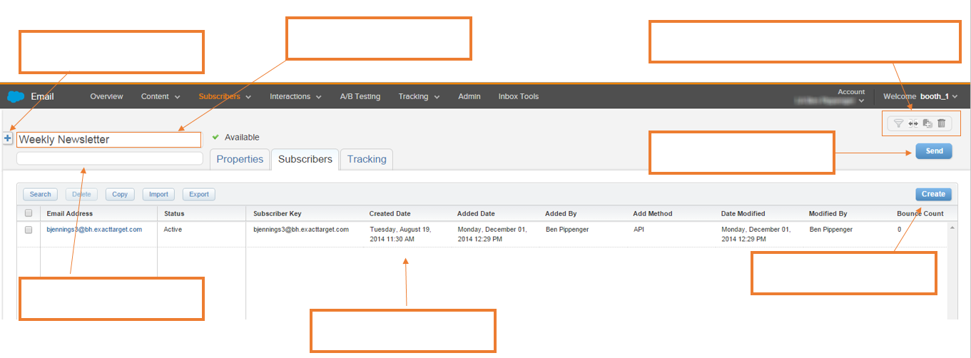
The Subscribers tab is the initial screen you will see when you choose a list. Here you will see all of the subscribers included in your list. Fill in the blanks to get a better idea of how to manage your lists.

Properties Tab

The properties tab shows general information about your list and also shows a count of how many subscribers are in the list. Fill in the blanks to learn more about your list’s properties.
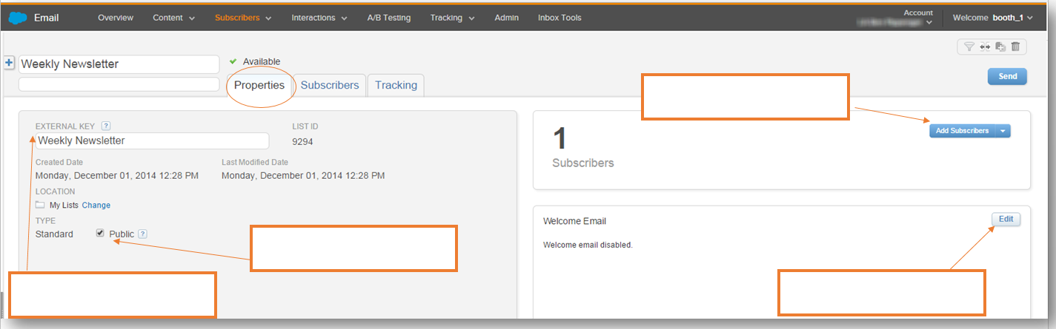

Tracking Tab

The tracking tab is the final step of your list navigation. Here you will see the most recent sends as well as your list composition. Fill in the blanks to see how you can track the subscribers in your list.
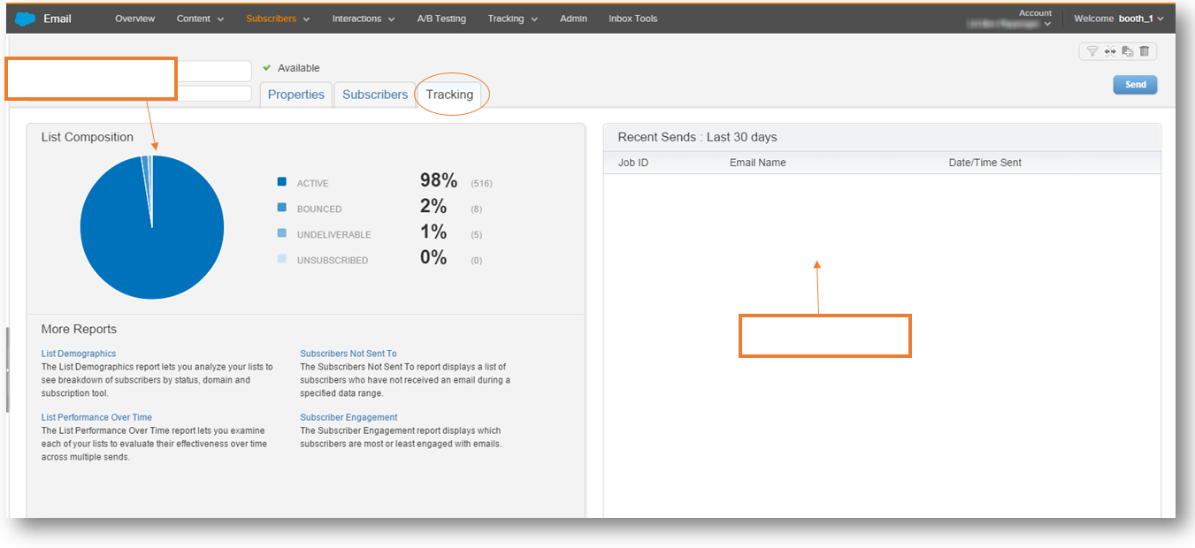

Still have questions? List out your open questions below and use help.exacttarget.com to find your answers. If you run into any difficulties finding answers, remember you can always reach out to Global support at help@exacttarget.com .

Have a question about your account? We have an answer.
Questions | Answers

Step 3: Creating Your Email

Path to Email Success

You’ve learned a lot! Let’s take a second to review the Path to Email Success. In this section we will be focusing on getting organized with Portfolio, creating templates and making sure you have everything ready to send your email.

Portfolio

Content Organization

For the next activity, let’s think of how you are going to organize your Content. Outline your folder structure within Portfolio and how you plan on utilizing the folders.

Content Organization
Folder Name | Images Included | Content Included | Media Files Included
Folder Name | Images Included | Content Included | Media Files Included

Email Building Checklist

Before you get started building an email, let’s make sure you have everything you need. Refer to this checklist as you begin building your emails and before you know it, you’ll be a pro!

Email Checklist

Are all of your images created?

Have you checked the file types that are supported?

Have you created a banner?

Do you have all of your content uploaded into Portfolio?

Do you have your content placement identified?

How many images/ content areas will you need?

Have you chosen a template?

Have you reviewed the Template Size Guidelines
Will you need to build HTML code outside of the app? | Y or N

Do you know your hexidecimal color codes?

Do you know the border color for the banner, if needed?

Do you know the background color, if needed?

Do you have a header that is less than 600 pixels?

Do you have a subject line?

Do you have your preheader identified?

Template Selection

Trying to figure out what templates work for you? Go ahead and pick a few that you think might be useful for different emails.

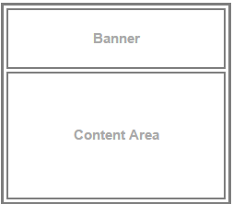
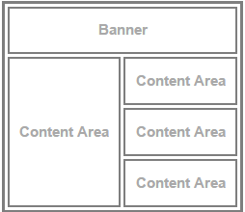
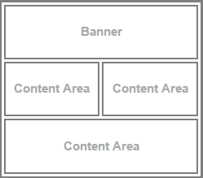
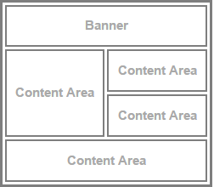

A ________________ B _________________ C _________________ D _________________
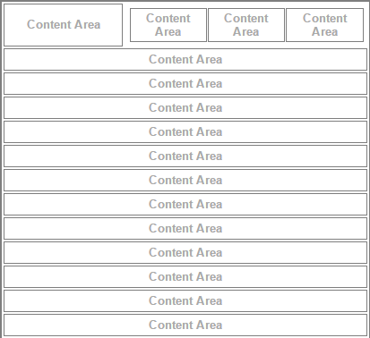
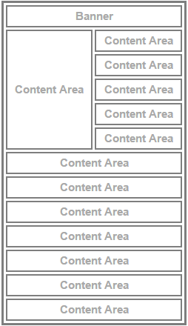
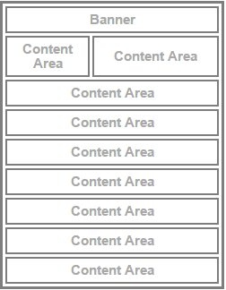

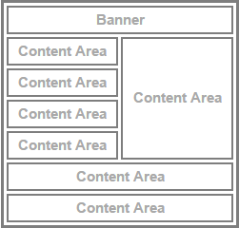

E _________________ F _________________ G _________________ H _________________
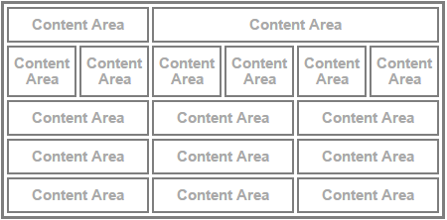
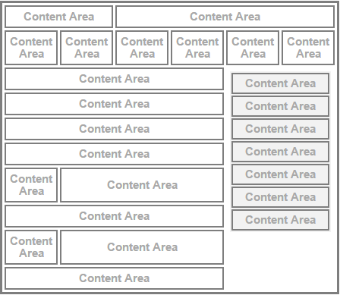
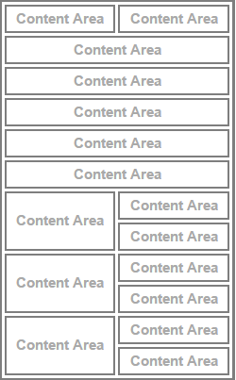

I _________________ J _________________ K _________________

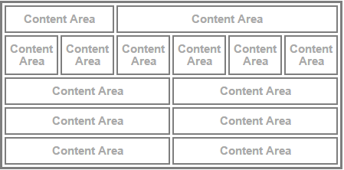
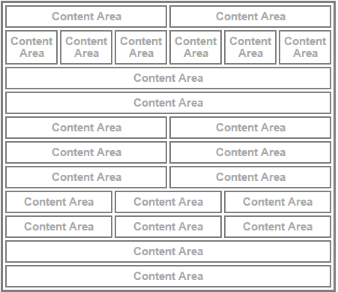

L _________________ M __________________

Content Forms

Consider the different forms of content and list how you can utilize them in your emails
Content Forms | How will you use them?
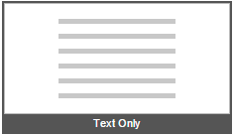

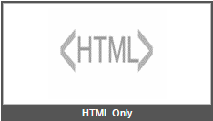

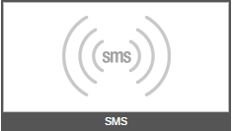

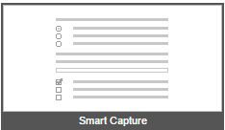

- Hexidecimal Color Code

Use this next activity to gather the correct hexadecimal color codes for your emails. Then you’ll be able to quickly refer back to it if you need to add a spice of color! Different colors may need to be used for different parts of your email.
Example: FFFFFF used for Border Color

Hexidecimal Color Code
Code # | When to use this color

- HTML Checklist

In order to create an HTML template, you need ensure the appropriate additions are made to your HTML code. Use this as a checklist to have a completed HTML code before creating a template.

HTML Checklist
Email Open Tracking
Content Areas
Tracking Alias
CAN-SPAM Compliance
Personalization Strings

Still have questions? List out your open questions below and use help.exacttarget.com to find your answers. If you run into any difficulties finding answers, remember you can always reach out to Global support at help@exacttarget.com .

Have a question about your account? We have an answer.
Questions | Answers

Step 4: Testing & Sending Email

- Workflow

Below is a diagram for the workflow you will walk through when testing and sending an email.

- Before you Send

You want to make sure you send the perfect email. This list will help you

Before you Send Checklist
Review the deliverability tips to ensure that your email reaches as many subscribers as possible.

Run the Spell Check in the content areas in your email. This is done within each content box by clicking the Spell Check icon, or by selecting Edit > Check Spelling.

Preview your email using Send Preview

Run Content Detective and make any necessary updates
Validate your email
Perform a test delivery of your email

- Test Sending

Before you begin testing, think about who you want to receive your test emails. These may include subscribers who are approvers, key stakeholders, and additional members of your email team.

List the email addresses that you would like your test emails to be sent to. You can send to up to 5 email addresses at one time.

Test Email Addresses
1.
2.
3.
4.
5.

- Sending Your Email

Each type of send option has different steps. Let’s keep organized by referring to the following guides for each unique type of send.

Test Send | Simple Send | Guided Send
From the send menu, select Test Send | From the send menu, select Simple Send | From the send menu, select Guided Send
Enter up to five email addresses to receive the test send | Review Subject and From Name, select a List for sending, and a send data and time | Click Next on the first screen of the Wizard
Click Send | Click Send | Select the list(s) or group(s) to send to
Confirmation is displayed on screen | Confirm Send | Select Exclusion Lists (if required)
 |  | Modify the subject, From Options, Send Options, and Test Options (if required)
 |  | Select to send the email immediately, or schedule for a specific date and time
 |  | Review and confirm the configuration
 |  | Click Send
 |  | Confirmation is displayed in the wizard when your email has been sent/scheduled. Click Finish

Still have questions? List out your open questions below and use help.exacttarget.com to find your answers. If you run into any difficulties finding answers, remember you can always reach out to Global support at help@exacttarget.com .

Have a question about your account? We have an answer.
Questions | Answers

Step 5: Tracking Your Email

- What is tracking?

Tracking is an aggregated collection of data that allows you to view critical elements. Which of the following elements do you think will help you track your emails?

Tracking Elements |  | How will it help?
Deliverability Rate
Undeliverables
Unique Opens
Total Opens
Open Rate
Unique Clicks
Total Clicks
Click Rate
Unengagement
Conversions
Surveys
Forward to a Friend Activity

- Tracking Grid

Which of the following elements do you think will help you track your emails and would be most valuable to having included in your workspace? Select which columns to display in the Tracking grid.

Tracking Grid
ID |  | Total Clicks
Name (This column is required to be visible) |  | Unique Click-Through Rate
Subject |  | Open Rate
From Name |  | Undeliverables
Date/Time Sent (This column is required to be visible) |  | Deliverability Rate
Status |  | Unsubscribes
Emails Sent |  | Unsubscribes Rate
Delivered |  | Survey Responses
Unique Opens |  | Unique Conversions
Total Clicks |  | Total Conversions
Unique Clicks |  | FTAF-Forwarders
Total Clicks |  | FTAF- Recipients
 |  | FTAF- Subscribers

- Creating Lists from Tracking Data

Creating a list from your tracking data is very important. Follow along with the steps below to get you through your first list creation, then you’ll be a pro!

Creating a List from Tracking Data
- Click the hyperlinked item you would like to create a list for
- Click Copy All in the toolbar
- Select to add to an Existing List or New List
    - Existing List: Select the list from the dropdown
    - New List: Enter a Name, description and visibility
- Click Copy

- How to Share

Certain tabs allow you to create a PDF, Excel file or both. Before starting to track your subscriber data you’ll need to know what form of tracking information your team or certain individuals would like to view. Use the below table to help outline who you will send tracking to, how you will send it over, and how frequently you will send it.

Tracking Information
Team or Employee Name | Document Type | How often do they need it?
 | PDF Excel | Daily Weekly Bi Weekly Monthly Bi Monthly Other ________________________
 | PDF Excel | Daily Weekly Bi Weekly Monthly Bi Monthly Other ________________________
 | PDF Excel | Daily Weekly Bi Weekly Monthly Bi Monthly Other ________________________
 | PDF Excel | Daily Weekly Bi Weekly Monthly Bi Monthly Other ________________________
 | PDF Excel | Daily Weekly Bi Weekly Monthly Bi Monthly Other ________________________
 | PDF Excel | Daily Weekly Bi Weekly Monthly Bi Monthly Other ________________________
 | PDF Excel | Daily Weekly Bi Weekly Monthly Bi Monthly Other ________________________
 | PDF Excel | Daily Weekly Bi Weekly Monthly Bi Monthly Other ________________________
 | PDF Excel | Daily Weekly Bi Weekly Monthly Bi Monthly Other ________________________

Still have questions? List out your open questions below and use help.exacttarget.com to find your answers. If you run into any difficulties finding answers, remember you can always reach out to Global support at help@exacttarget.com .

Have a question about your account? We have an answer.
Questions | Answers

